**Big Mountain Resort Report** *by Tamara Horne*

Big Mountain Resort is a beautiful and popular ski and snowboarding resort which does not do itself or its stakeholders justice by trusting the competition to set the price. Using the average price of the competitors within the market as the sole data point has left the resort is a position where they are undercutting their own profits and neglecting to understand their own value. The new method of data utilization we have developed shows justification for a higher ticket price and provides a means by which future upgrades or downgrades in resort features can be easily evaluated to predict their impact both on ticket price and overall profit.

Big Mountain resort executives were wise the seek a replacement model for their current pricing strategy. They could see that with the purchase of a new chair with a price tag of $1,540,000, it was a good time to gain more insight into whether or not their ticket price could be increased to counteract the higher operating expenses, or whether they would need to decrease costs in other areas in order to maintain or increase profitability. So we began the journey of studying the available data to find answers.

First, we explored the available data which contained 330 rows of information on features and ticket prices from ski resorts across the United States. We removed entries which were devoid of price information, we carefully corrected one inaccuracy and discarded another whose accompanying information was deemed inconsequential, and we added and cleaned freshly sourced state-specific population and area data from wikipedia.org. By the end of this phase, we had refined the goal to be the prediction of the weekend ticket price for the ski resort.

In the exploratory phase, we looked for correlation between price and features. We determined that there was not a strong relationship between state and ticket price so the state names were dropped. We did find a positive correlation, though, between price and the number of fast quads, runs, total chairs, and the amount of snow making and, to a lesser degree, a few other features.

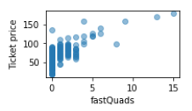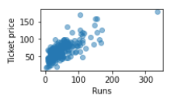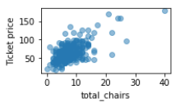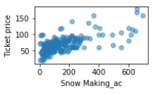

Before diving into preprocessing, we got a baseline idea of performance by just taking the average price to see how well that did as a predictor. We then built a linear model and also a random rainforest model to show the relationship between price and features. Both models were better predictors than the baseline average of price, but the rainforest model had the lower cross-validation mean absolute error by almost $1 and also exhibited less variability. So, we decided to use that model going forward. We also did a check to determine whether collecting data might help improve the model and found that it would not.

The final modeling had us looking at the where Big Mountain sits in relation to all the other resorts in regards to eight most important features. This modeling helps us gain a deeper understanding of where Big Mountain is excelling in relation to the competition and where there is room for growth.

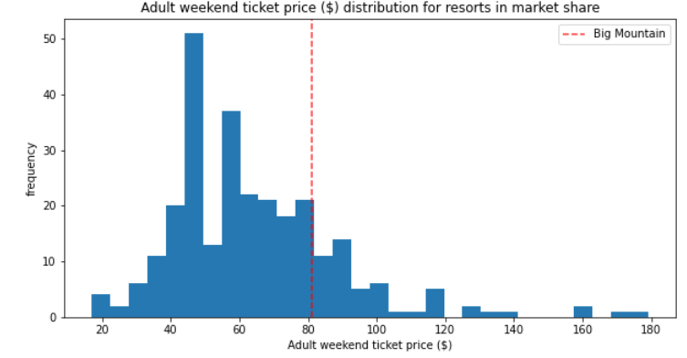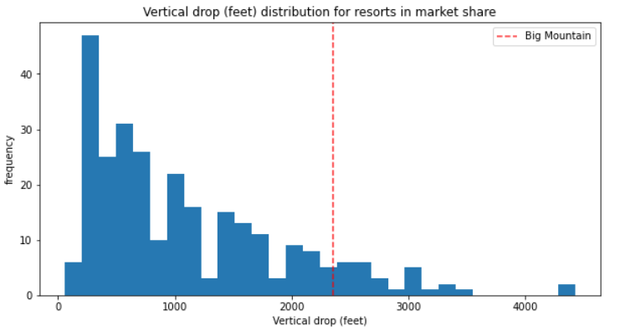

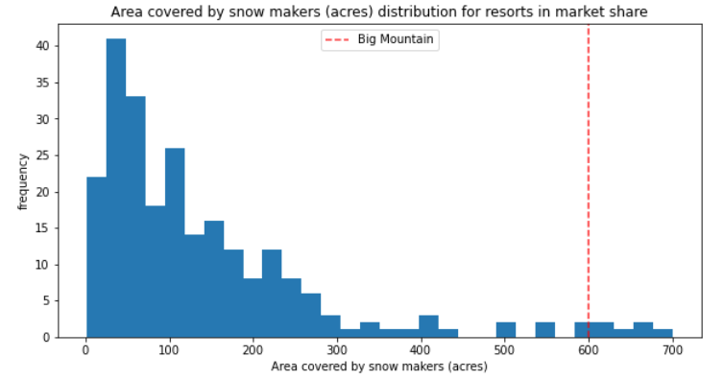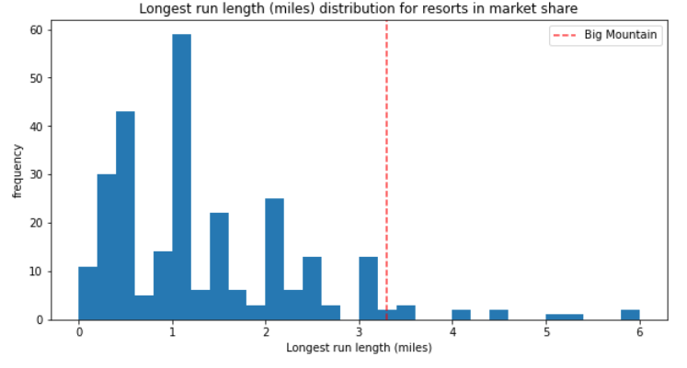

Now, with a fuller understanding of the relationship between price and features, we were able to see that the current price of $81 that Big Mountain is charging for an adult weekend ticket is undervalue. Our modeling suggests a price of $95.87 with an expected mean absolute error of $10.39. So the company could definitely increase the ticket price without needing to make any other changes to the resort. In this vein, If the company looked at increasing price to cover the cost of the recently added lift, ie recuperating $1.54M spread over 350,000 visitors each buying an average of 5 tickets, the ticket price would need to increase by $0.88, and an increase of that amount is definitely supported by the data.

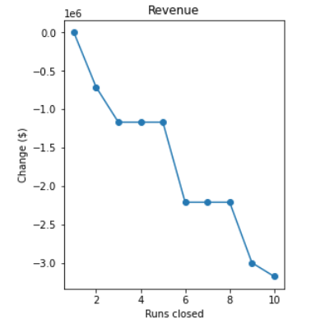

However, there were a few additional scenarios the executives wanted to consider. These scenarios included closing down some runs, and various combinations of adding a run to increase the total vertical drop, and/or increasing the snow making area. The scenario which showed the greatest support for an increase in ticket price included adding a run that would increase the vertical drop by 150 feet along with a new chair lift to support it. This would justify a ticket price increase of $1.99. If the company does still want to look into closing runs as a cost reduction technique, I would recommend gathering additional data about the costs to operate each run individually before proceeding. The affect on ticket price is only half the story.

In the near term, I would recommend Big Mountain consider increasing their ticket price to $85 which would still be slightly below the MAE for the suggested ticket price. Then they could consider smaller additional increases in price after that. I would also suggest Big Mountain consider adding the run and chair lift to increase the total vertical drop but only after looking at data containing the cost associated with the addition to make sure it is less than the expected $3,474,638 increase in revenue the improved feature is expected to generate over the course of the season.